Cellselection GUI Instructions:

Select GEMs channel (if other channels added in code select channels to use) and click Display. An image will show on the screen as shown below.

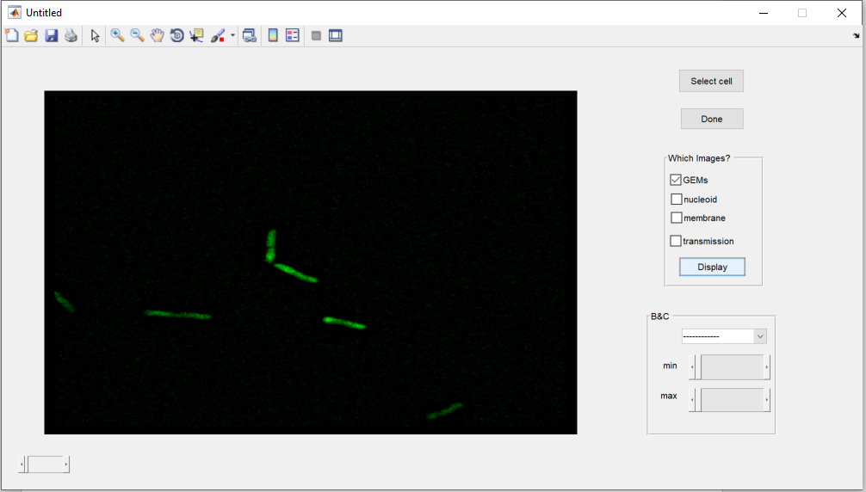

Next click Select cell and click on the first 4 vertex around the cell and right click to close shape. Double click on cell outline to save cell. A pop-up message will appear with Cell selected message. Repeat for all cells of interest. Once done selecting cells click Done. Positions will be returned in variable a, and displayed in the Command Window.

